VIDHYADEEP INSTITUTE OF COMPUTER & INFORMATION TECHNOLOGY,ANITA-KIM.



VEER NARAMD SOUTH GUJARAT UNIVERSITY
PROJECT REPORT
ON
“Cloud Gameing”
AS A PARTIAL REQUIREMENT FOR THE DEGREE

OF
BECHOLOR OF COMPUTER APPLICATION( BCA) Year 2023-2024
(TYBCA 6th Semester)

Internal Guide:- SubmittedBy:-
Mis.Priti Dhimmar Neel Dhameliya



VIDHYADEEP INSTITUTE OF COMPUTER & INFORMATION TECHNOLOGY

CERTIFICATE
This is to certify that project report,submitted for the project entitled “Neural Network” has been carried out by “Neel dhameliya” at BCA department of vidhyadeep institute of computer & information technology, kim for partial fulfilment of BCA degree to be awarded by veer narmad south Gujarat university. this project work has been carried out under my supervision and is to my satisfaction.

Place :- kim
Date :-

Internal Guide I/C Principal
Mis.Priti Dhimmar Dr..Himansu Patel

Cloud Gaming
Cloud gaming, sometimes called gaming on demand or game streaming, is a type of online gaming that runs video games on remote servers and streams the game's output (video, sound, etc) directly to a user's device, or more colloquially, playing a game remotely from a cloud. It contrasts with traditional means of gaming, wherein a game is run locally on a user's video game console, personal computer, or mobile device.

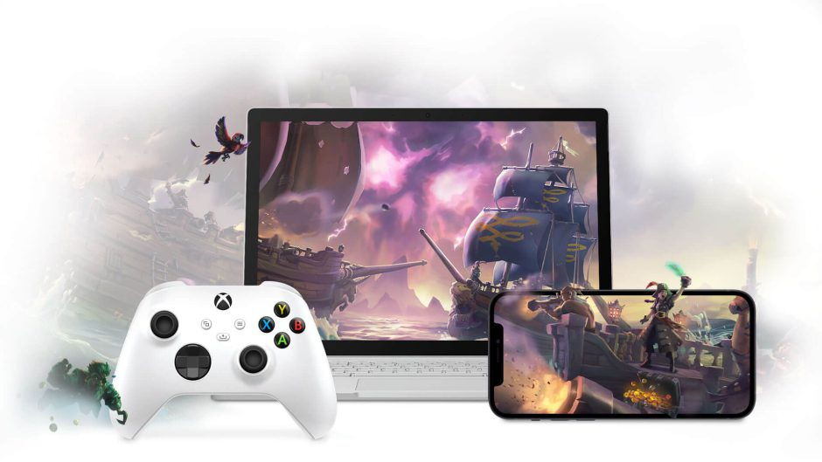
This Photo by Unknown Author is licensed under CC BY
Absolutely, cloud gaming represents a significant shift in how games are played and accessed. By leveraging powerful remote servers to handle the heavy lifting of game processing, cloud gaming allows users to play high-quality games on devices that might not have the necessary hardware requirements. This has the potential to democratize gaming, making it more accessible to a wider audience.
One of the key benefits of cloud gaming is its ability to enable "play anywhere" functionality. As long as you have a decent internet connection, you can access your games from virtually any device, whether it's a smartphone, tablet, laptop, or smart TV. This flexibility is particularly appealing to gamers who are constantly on the move or who may not have access to a dedicated gaming setup.
However, cloud gaming is not without its challenges. The most significant hurdle is latency, or the delay between a player's input and the game's response. Because the game is being processed remotely and then streamed to the player's device, even minor delays in internet connection can result in noticeable lag, which can negatively impact gameplay, especially in fast-paced or competitive games.
Additionally, the success of cloud gaming depends heavily on the quality and reliability of internet infrastructure. Users with slow or unstable internet connections may find the experience frustrating or unplayable.
Despite these challenges, cloud gaming has gained momentum in recent years, with major players like Google, Microsoft, and NVIDIA investing heavily in cloud gaming platforms. As technology continues to improve and internet infrastructure becomes more robust, cloud gaming has the potential to become the dominant way that games are played and enjoyed.

== Background ==
Cloud gaming platforms operate in a similar manner to remote desktops and video on demand services; games are stored and executed remotely on a provider's dedicated hardware, and streamed as video to a player's device via client software. The client software handles the player's inputs, which are sent back to the server and executed in-game. Some cloud gaming services are based on access to a virtualized Windows environment, allowing users to download and install games and software as they normally would on a local computer.Cloud gaming can be advantageous as it eliminates the need to purchase expensive computer hardware or install games directly onto a local game system. Cloud gaming can be made available on a wide range of computing devices, including mobile devices such as smartphones and tablets, digital media players, or proprietary thin client-like devices. Some services may offer additional features to take advantage of this model, including the ability for a viewer to join a player's session and temporarily take control of the game.Due to their dependency on high-quality streaming video, cloud gaming services typically require reliable, high-speed internet connections with low latency. Even with high-speed connections available, traffic congestion and other issues affecting network latency can affect the performance of cloud gaming, and the ability to use a service regularly may also be limited by data caps enforced by some internet service providers.Further, the costs of cloud gaming shift from traditional distribution through retail outlets and digital storefronts to the data servers that run the cloud gaming services. Novel cost structures are required to cover these operating costs compared to traditional distribution.

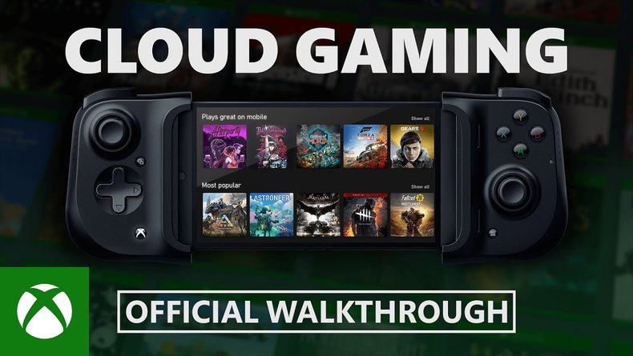
This Photo by Unknown Author is licensed under CC BY-SA-NC

== Infrastructure considerations ==
Cloud gaming requires significant infrastructure for the services to work as intended, including data centers and server farms for running the games, and high-bandwidth internet connections with low latency for delivering the streams to users. The network infrastructure required to make cloud gaming feasible was, for many years, not available in most geographic areas, or unavailable to consumer markets.A major factor in the quality of a cloud gaming service is latency, as the amount of delay between the user's inputs and when they take effect can affect gameplay — especially in fast-paced games dependent on precise inputs (such as first-person shooters and fighting games). Attempts to reduce latency include the use of caching as the cached data can be "stored locally ... and can be retrieved when required."The provider's dedicated hardware can be upgraded over time in order to support higher resolutions and frame rates for the rendering and streams. The Quality of Experience (QoE) that measures the user's general level of satisfaction also needs to be brought into consideration during the development phase of cloud gaming.

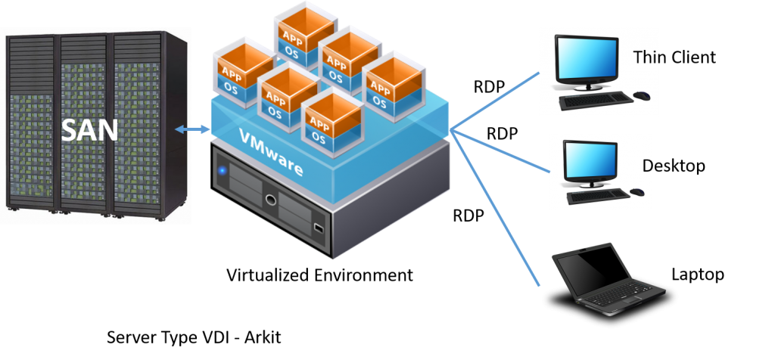
This Photo by Unknown Author is licensed under CC BY-NC

== History ==
- Early 2000s: The idea of remotely hosting games and streaming them to users' devices begins to emerge. However, internet speeds and technology limitations hinder widespread adoption.
- Mid to Late 2000s: Companies start experimenting with cloud gaming platforms, but the technology is still in its infancy, and there are significant technical challenges to overcome, including latency and bandwidth constraints.
- 2010s: Cloud gaming starts to gain traction as internet infrastructure improves and technology advances. Companies like OnLive (founded in 2007) and Gaikai (founded in 2008) pioneer cloud gaming services, allowing users to stream games directly to their devices.
- 2012: Sony acquires Gaikai for $380 million, signaling a growing interest in cloud gaming from major players in the industry.
- 2013: NVIDIA launches its cloud gaming service, GeForce NOW, initially as a beta program. It allows users to stream games from NVIDIA's servers to their devices.
- 2019: Google enters the cloud gaming market with the launch of Stadia. Leveraging Google's infrastructure, Stadia allows users to play high-quality games without the need for specialized hardware, streaming directly from Google's servers to their devices.
- 2020: Microsoft launches Xbox Cloud Gaming (formerly known as Project xCloud) as part of its Xbox Game Pass Ultimate subscription service. This allows subscribers to stream Xbox games to their devices, expanding the reach of Xbox gaming beyond traditional consoles.
- 2021-2022: Cloud gaming continues to evolve, with improvements in technology leading to better streaming quality and reduced latency. Major players like Google, Microsoft, NVIDIA, and others invest heavily in cloud gaming infrastructure and services, indicating a growing belief in its potential.
Overall, the history of cloud gaming is one of steady progress, with advancements in technology and infrastructure paving the way for a future where gaming becomes more accessible and flexible than ever before.
Top of Form

=== Early attempts ===
The first demonstrated approach of cloud gaming technology was by startup G-cluster (short for Game Cluster), which introduced its product at the 2000 E3, and released around 2003. In their initial model around 2005, G-cluster provided PC games that ran on their servers, using video-on-demand service providers, set-top box manufacturers, and middleware software providers to help provide their service to network operators, and then offered the games through portals to end users. By 2010, due to changes in the market, G-cluster changed their model to work through a large server manufacturer to provide their games to the network operators and directly to users. This refocusing was necessitated by the increased available of free-to-play games available for personal computers, drawing them away from G-cluster's service, so G-cluster opted to focus on Internet Protocol television (IPTV) users instead, which had a potential target of about three million users in 2010. French telco SFR launched G-cluster gaming service in 2010 for its end users and Orange followed suit in 2012 offering the gaming service for its customers. Both services have been commercially operational ever since offering cloud gaming for their customers on TV and mobile.
In early 2003, another attempt was announced by American company Infinium Labs, which intended to revolutionize the market of home entertainment with their Phantom video game console, a device that was envisioned to be capable of providing an on-demand video game delivery service via monthly online subscription. The Phantom was designed to run PC games, thus making it compatible with hundreds of titles from the start, and was to be sold at a much lower price than high-end PC gaming rigs. A functioning prototype was first presented at the E3 2004, running Unreal Tournament 2004, and then again at QuakeCon, where it was shown to be capable of perfectly operating Quake 3 Arena on a dedicated server. After a couple years of setbacks, the company bankrupted in 2008, with the Phantom console never officially released to the market, becoming one of the most popular vaporware of recent times.
Video game developer Crytek began the research on a cloud gaming system in 2005 for Crysis, but according to their CEO Cevat Yerli, they halted development in 2007 to wait until the infrastructure and cable Internet providers were able to complete the task and the cost of bandwidth to decline.

- G-cluster (2000s): G-cluster, a Finnish company founded in 2000, was one of the pioneers of cloud gaming. They developed a platform that allowed users to stream video games over the internet to various devices, including PCs, TVs, and set-top boxes. However, the technology faced challenges due to limited internet speeds and hardware capabilities at the time.
- OnLive (2009): OnLive, founded in 2007 and launched in 2009, was one of the first widely recognized cloud gaming platforms. It allowed users to stream games from remote servers to their devices, eliminating the need for high-end hardware. OnLive faced significant technical and financial challenges, but it played a crucial role in popularizing the concept of cloud gaming.
- Gaikai (2010): Gaikai, founded in 2008, focused on streaming high-quality video games directly to users' web browsers. The company's technology allowed users to play games instantly without the need for downloads or installations. Gaikai gained attention for its innovative approach to cloud gaming and was eventually acquired by Sony in 2012.
- PlayStation Now (2014): While not strictly a cloud gaming platform in its earliest form, PlayStation Now represented Sony's entry into the cloud gaming space. Initially launched as Gaikai's technology integrated into the PlayStation ecosystem, PlayStation Now allowed users to stream a library of PlayStation games to their PlayStation consoles and eventually other devices like PCs.
These early attempts at cloud gaming faced numerous challenges, including technical limitations, internet infrastructure constraints, and skepticism from both gamers and industry insiders. However, they laid the foundation for future advancements in cloud gaming technology and helped pave the way for the services we see today.
Top of Form

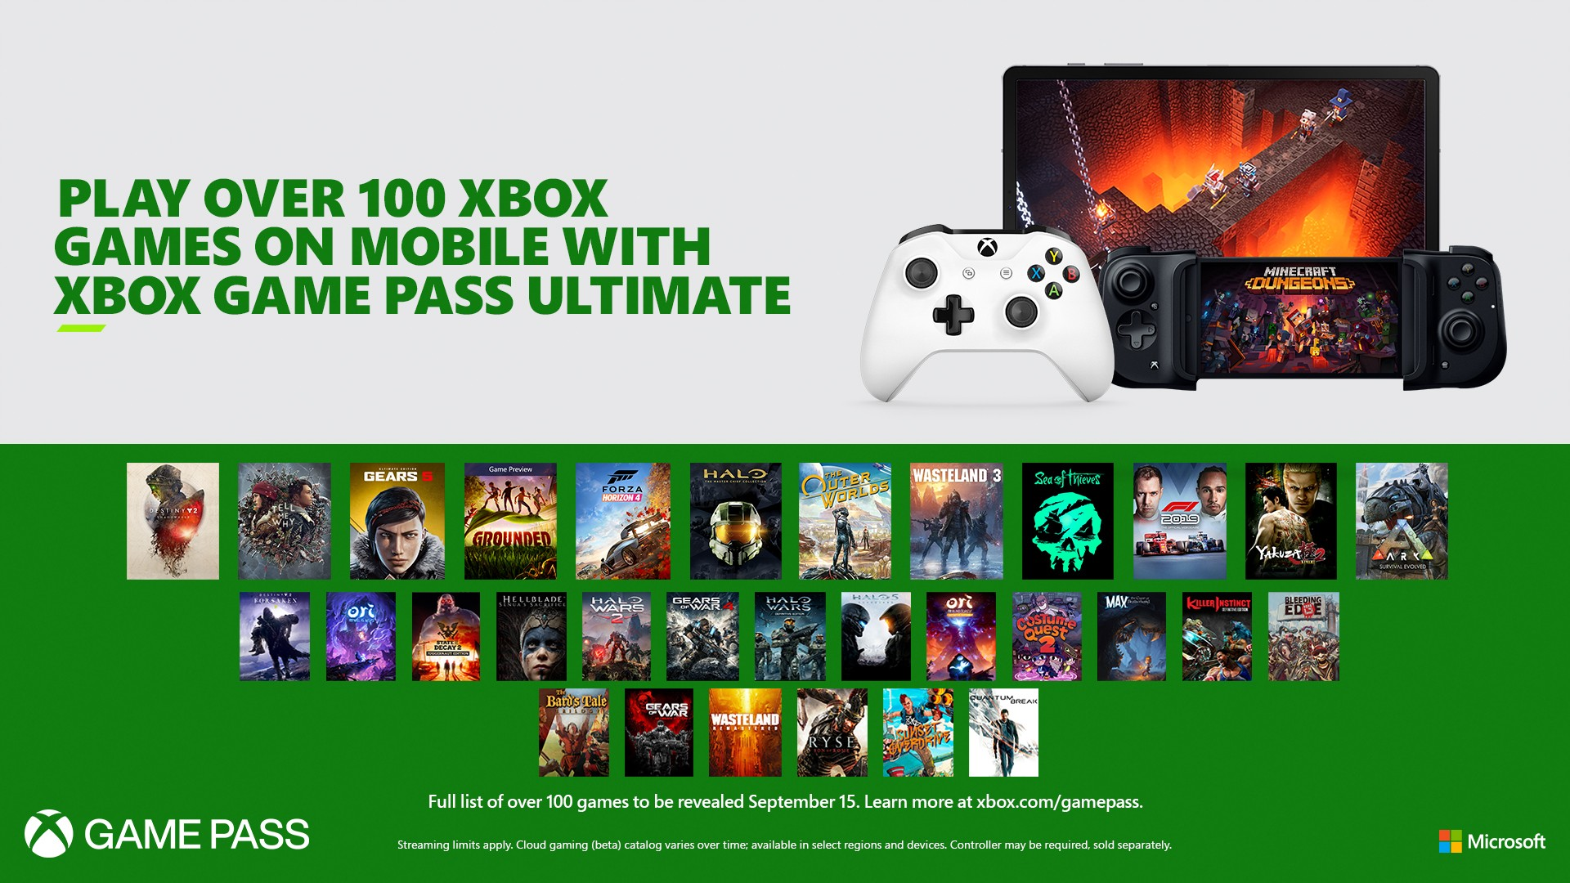
This Photo by Unknown Author is licensed under CC BY-SA

=== OnLive and Gaikai ===
Entrepreneur Steve Perlman revealed OnLive at the March 2009 Game Developers Conference. Perlman stated that with improvements in data and video compression as well as capabilities of smartphones, the potential for cloud gaming was now timely. OnLive was officially launched in June 2010, alongside sale of its OnLive microconsole. While OnLive had acquired some support from large publishers like Ubisoft, 2K Games and THQ, they found it difficult to get other publishers onboard as they were wary of the subscription price model.Simultaneous to OnLive, another startup Gaikai was announced by David Perry in 2010. Gaikai opted to approach streaming of game demos rather than full games, making the service a form of online advertising for games. Gaikai gained far more publisher support, including Electronic Arts which OnLive had been trying to bring back to their service. Gaikai was acquired by Sony Computer Entertainment in July 2012 for $340 million, and by October 2012, was offering PlayStation games. Ultimately, the technology behind Gaikai was used as the foundation for PlayStation Now, first introduced in 2014.OnLive was never profitable, and after a possible acquisition by HP Inc. fell through, OnLive's assets were acquired by a newly formed entity named "OL2," which was capitalized by Gary Lauder of Lauder Partners in 2012 at $4.8 million, a fraction of OnLive's valuation from 2010. A mass layoff (2/3 of staff) was conducted to reduce operating costs. Under Lauder Partners, the new OL2 attempted to pivot its business model to allow streaming of games already owned by the user, but this failed to be profitable. OnLive and OL2's intellectual property was acquired by Sony Computer Entertainment in April 2015, but then closed it down about a month later. As stated by The Verge, the acquisition of both Gaikai and OnLive's intellectual property gave Sony access to a range of patents covering cloud gaming.

OnLive:
- Founding and Launch: OnLive was founded in 2007 by Steve Perlman, with the vision of revolutionizing the way video games were played by leveraging cloud technology. The service was officially launched in 2009.
- Technology: OnLive's platform allowed users to stream high-quality video games over the internet to various devices, including PCs, Macs, TVs, and even mobile devices. The games were hosted and processed on remote servers, with the video and audio streamed to the user's device, and their inputs transmitted back to the servers in real-time.
- Game Library: OnLive offered a diverse library of games from various publishers, including both AAA titles and indie games. Users could purchase games individually or subscribe to a monthly subscription service for unlimited access to a selection of titles.
- Challenges: OnLive faced several challenges, including skepticism from gamers and industry insiders, as well as technical hurdles such as latency issues and bandwidth requirements. Despite these challenges, OnLive played a significant role in popularizing the concept of cloud gaming.
- Closure: In 2015, OnLive announced that it would be shutting down its service and selling its patents to Sony Interactive Entertainment. The closure marked the end of an era for the company but also served as a learning experience for the nascent cloud gaming industry.
Gaikai:
- Founding and Acquisition: Gaikai was founded in 2008 by David Perry, with a focus on streaming high-quality video games directly to users' web browsers. The company gained attention for its innovative approach to cloud gaming and was eventually acquired by Sony Computer Entertainment (now Sony Interactive Entertainment) in 2012 for $380 million.
- Technology: Gaikai's technology allowed users to play video games instantly without the need for downloads or installations. Games were hosted and processed on remote servers, with the video and audio streamed to the user's device. Gaikai's platform was integrated into various devices and services, including PlayStation consoles and Sony's BRAVIA TVs.
- PlayStation Now: Following its acquisition by Sony, Gaikai's technology formed the basis of PlayStation Now, Sony's cloud gaming subscription service. PlayStation Now allows users to stream a library of PlayStation games to their PlayStation consoles, PCs, and other supported devices.
- Legacy: Gaikai's acquisition by Sony and its integration into PlayStation Now helped solidify Sony's presence in the cloud gaming market. The technology and expertise gained from Gaikai continue to play a crucial role in Sony's cloud gaming strategy.
Overall, OnLive and Gaikai were instrumental in laying the groundwork for cloud gaming, demonstrating the potential of streaming technology to change the way games are played and accessed. Though both companies faced challenges and ultimately followed different paths, their contributions to the industry are significant and have helped shape the landscape of modern gaming.

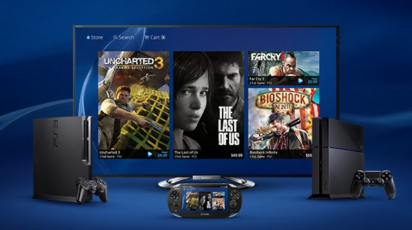
This Photo by Unknown Author is licensed under CC BY-SA

=== Recent advances ===
Nvidia first announced its cloud gaming service, Nvidia Grid (later rebranded as GeForce Now), as a combination of hardware using its graphics processing units and software in May 2012, initially intending to partner with Gaikai for games on the service. Ubitus GameCloud was also introduced alongside Nvidia's Grid. GameCloud was designed as white-label service based on Nvidia's Grid that other providers could use to offer game streaming to their customers.Grid was formally introduced as part of its Nvidia Shield Android TV device during the 2013 International Consumer Electronics Show. Grid/GeForce Now launched with services provided by several cloud gaming partners including Agawi, Cloudunion, Cyber Cloud, G-cluster, Playcast, and Ubitus. The Grid service was first launched in North America in November 2014 where a limited number of games were made available, and then later expanded to computers in 2017, including support for importing a user's Steam and Epic Games Store library to run on the remote instance. This importing model was criticized by publishers including Activision Blizzard and Bethesda Softworks, as purchases were only intended for personal computers and not through cloud gaming. The publishers forced NVidia to pull these games from their service.In 2014, Dragon Quest X was brought to Nintendo 3DS in Japan using Ubitus for the streaming technology.In 2017, the French startup Blade launched a service known as Shadow, where users are able to rent a remote Windows 10 instance on a datacenter, with allocated access to an Intel Xeon processor and Nvidia Quadro graphics. The service is geographically-limited based on proximity to one of its datacenters; it initially launched in France, but began expanding into the United States in 2019.In May 2018, Electronic Arts acquired cloud gaming assets and talent from GameFly for an undisclosed amount. EA subsequently announced "Project Atlas", a project to explore the integration of artificial intelligence, machine learning, and Frostbite engine technology to create a "unified" platform to "remotely process and stream blockbuster, multiplayer HD games with the lowest possible latency, and also to unlock even more possibilities for dynamic social and cross-platform play." That month, Google and Microsoft also announced cloud gaming initiatives, with Google beginning to pilot "Project Stream" (including a closed beta featuring Assassin's Creed Odyssey running via a client in the Google Chrome web browser, and Microsoft announced the upcoming Project xCloud, leveraging Microsoft Azure technology.At the Game Developers Conference in 2019, Google officially announced its cloud gaming service Stadia, which officially launched on November 19 of that year. In May, Sony announced a partnership with Microsoft to co-develop cloud solutions between divisions, including gaming.Apple Inc., which makes the iOS platform for iPhones and iPads, had looked to block cloud gaming apps on its service in mid-2020. They argued that cloud gaming services allowed developers to add games onto the iOS system that bypassed the normal checks they perform on any app before it is added to the App Store, and thus violated their terms of service. However, in September 2020, Apple altered its rules that allowed cloud gaming apps to work on iOS, with restrictions that each game must be offered as an individual download on the iOS store which the user must use before playing, though catalog apps as part of the service can list and link to these games. Both GeForce Now and Stadia announced plans in November 2020 to release iOS versions of their streaming services as progressive web applications that would be run through a Chrome or Safari browser on iOS devices, as allowed for by Apple, to support cloud gaming. Microsoft has also announced plans to use a similar approach to bring the xCloud game streaming technology to iOS via the browser sometime in early 2021.Amazon introduced its own cloud gaming service Luna in September 2020. Games on the service will be offered via a channel-style subscription service, with Amazon's own games and those from Ubisoft available at the service's launch.Asus and Intel announced ongoing hardware supply, research & development and software optimization alongside Boosteroid cloud gaming platform in November 2020.Nintendo currently has games on Nintendo Switch that primarily run on cloud gaming such as Control, Hitman 3, Marvel's Guardians of the Galaxy, and the Kingdom Hearts franchise, using Ubitus.
- Technological Improvements: Advances in cloud infrastructure, networking technology, and video compression algorithms have led to significant improvements in streaming quality and reduced latency. Companies like Google, Microsoft, and NVIDIA have invested heavily in optimizing their cloud gaming platforms to deliver a smoother and more responsive gaming experience.
- 5G Integration: The rollout of 5G networks has the potential to further enhance cloud gaming by providing faster and more reliable internet connectivity, particularly for mobile users. 5G's lower latency and higher bandwidth capabilities make it well-suited for streaming high-quality games on the go.
- Expanding Game Libraries: Cloud gaming services have been expanding their game libraries to offer a wider selection of titles to subscribers. This includes not only popular AAA titles but also indie games and older classics. Additionally, some platforms offer exclusive games and content to attract users.
- Cross-Platform Support: Many cloud gaming platforms now support cross-platform play, allowing users to access their games and progress across multiple devices seamlessly. This flexibility enables users to start playing a game on one device and continue where they left off on another, without any interruptions.
- Partnerships and Acquisitions: Companies in the gaming industry have been forming strategic partnerships and making acquisitions to strengthen their positions in the cloud gaming market. For example, Microsoft's acquisition of Bethesda parent company ZeniMax Media in 2020 brought a wealth of game IP into its Xbox Game Pass subscription service, which includes cloud gaming.
- Integration with Subscription Services: Cloud gaming services are increasingly being integrated into existing subscription models. For example, Microsoft's Xbox Game Pass Ultimate subscription includes access to Xbox Cloud Gaming (formerly known as Project xCloud) at no additional cost, allowing subscribers to stream a wide selection of games to their devices.
- Competition and Innovation: The competitive landscape of cloud gaming continues to evolve, with new entrants entering the market and existing players constantly innovating to differentiate themselves. This competition is driving further advancements in technology and user experience, benefiting consumers.
Overall, recent advances in cloud gaming have made the technology more accessible, reliable, and compelling than ever before. As the industry continues to mature, we can expect to see even more exciting developments in the future.

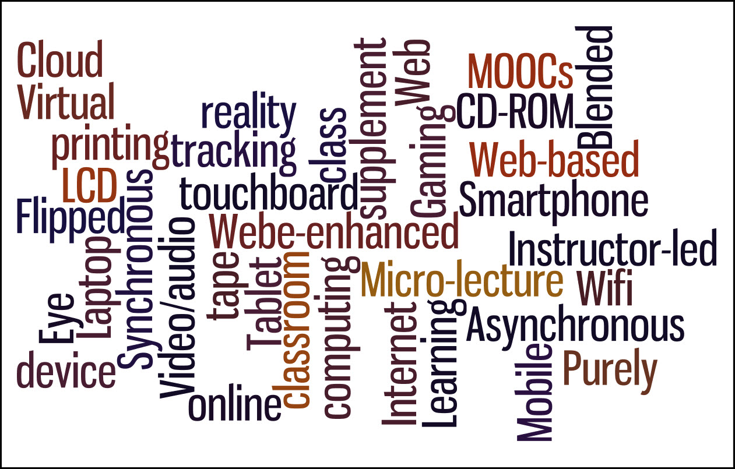
This Photo by Unknown Author is licensed under CC BY-SA

== Future ==
- Improved Streaming Quality: Future advancements in cloud infrastructure, networking technology, and video compression algorithms will likely lead to even higher-quality streaming experiences. Reduced latency, higher resolutions, and smoother frame rates will make cloud gaming almost indistinguishable from playing games locally on dedicated hardware.
- 5G and Edge Computing Integration: The widespread adoption of 5G networks and the development of edge computing infrastructure will further enhance the capabilities of cloud gaming. Lower latency, higher bandwidth, and edge computing's ability to process data closer to the user will result in more responsive and immersive gaming experiences, particularly for mobile users.
- Enhanced Interactivity and Social Features: Cloud gaming platforms will continue to innovate in terms of social and interactive features. Enhanced multiplayer experiences, seamless integration with social media platforms, and innovative ways for players to connect and interact in virtual worlds will become standard features of cloud gaming services.
- Integration with Augmented Reality (AR) and Virtual Reality (VR): As AR and VR technologies mature, cloud gaming platforms will likely integrate these immersive technologies to offer new gaming experiences. Cloud-powered AR and VR gaming will enable players to explore virtual worlds, interact with digital objects, and engage in multiplayer experiences like never before.
- AI and Machine Learning Integration: Cloud gaming platforms will leverage AI and machine learning algorithms to personalize gaming experiences, optimize game performance, and enhance player engagement. AI-driven features such as adaptive difficulty levels, intelligent matchmaking, and real-time player behavior analysis will become commonplace in cloud gaming.
- Expansion of Gaming Ecosystems: Cloud gaming will lead to the further blurring of traditional boundaries between gaming platforms and devices. Players will have the flexibility to access their games and progress seamlessly across multiple devices, including smartphones, tablets, PCs, smart TVs, and dedicated gaming consoles.
- New Business Models and Monetization Strategies: Cloud gaming will continue to disrupt traditional business models in the gaming industry. Subscription-based services, microtransactions, in-game advertising, and other innovative monetization strategies will evolve to meet the changing demands of players and maximize revenue for developers and publishers.
Overall, the future of cloud gaming looks incredibly promising, with the potential to revolutionize how games are played, accessed, and experienced. As technology continues to advance and consumer expectations evolve, cloud gaming will undoubtedly play an increasingly significant role in the gaming industry landscape.
Top of Form

This Photo by Unknown Author is licensed under CC BY-NC-ND

=== GPU resource sharing ===
A proposed method to improve game streaming's scalability is adaptive graphics processing unit (GPU) resource scheduling. Most cloud gaming providers are using dedicated GPUs to each person playing a game. This leads to the best performance but can waste resources. With better GPU resource scheduling algorithms, if the game does not fully utilize that GPU it can be used to help run someone else’s game simultaneously. In the past, “GPU virtualization was not used due to the inferior performance of the resource scheduling algorithm”. However new resource management algorithms have been developed that can allow up to 90% of the GPUs original power to be utilized even while being split among many users.

GPU resource sharing in gaming refers to the practice of dynamically allocating and managing graphical processing units (GPUs) to optimize performance and resource utilization during gameplay. This concept is particularly relevant in the context of cloud gaming, where multiple users may be accessing the same physical GPU resources simultaneously.
Here's how GPU resource sharing works in gaming:
- Virtualization: In cloud gaming environments, GPUs are often virtualized to allow multiple users to share the same physical hardware without interfering with each other's gaming experiences. Virtualization software divides the GPU's resources into virtual instances, each assigned to a specific user or game session.
- Resource Allocation: GPU resource sharing systems dynamically allocate GPU resources based on factors such as user demand, game requirements, and available hardware resources. This ensures that each user receives adequate GPU performance to maintain a smooth and responsive gaming experience.
- Load Balancing: To optimize performance and avoid overloading the GPU, load balancing algorithms may be used to distribute processing tasks evenly across available GPU resources. This helps prevent bottlenecks and ensures consistent performance for all users, even during peak usage periods.
- Quality of Service (QoS) Guarantees: In some cases, GPU resource sharing systems may prioritize certain users or game sessions based on factors such as subscription level, service tier, or performance requirements. This ensures that high-priority users receive the necessary GPU resources to meet their quality of service expectations.
- Latency Reduction: Efficient GPU resource sharing can help minimize latency, which is crucial for delivering a responsive gaming experience, especially in fast-paced or competitive multiplayer games. By optimizing resource allocation and reducing processing delays, GPU resource sharing systems contribute to lower overall latency in cloud gaming environments.
Overall, GPU resource sharing plays a vital role in maximizing the efficiency and performance of cloud gaming platforms, allowing multiple users to enjoy high-quality gaming experiences without the need for dedicated gaming hardware. As technology continues to evolve, advancements in GPU virtualization, resource management, and optimization techniques will further enhance the capabilities of GPU resource sharing in gaming.
Top of Form

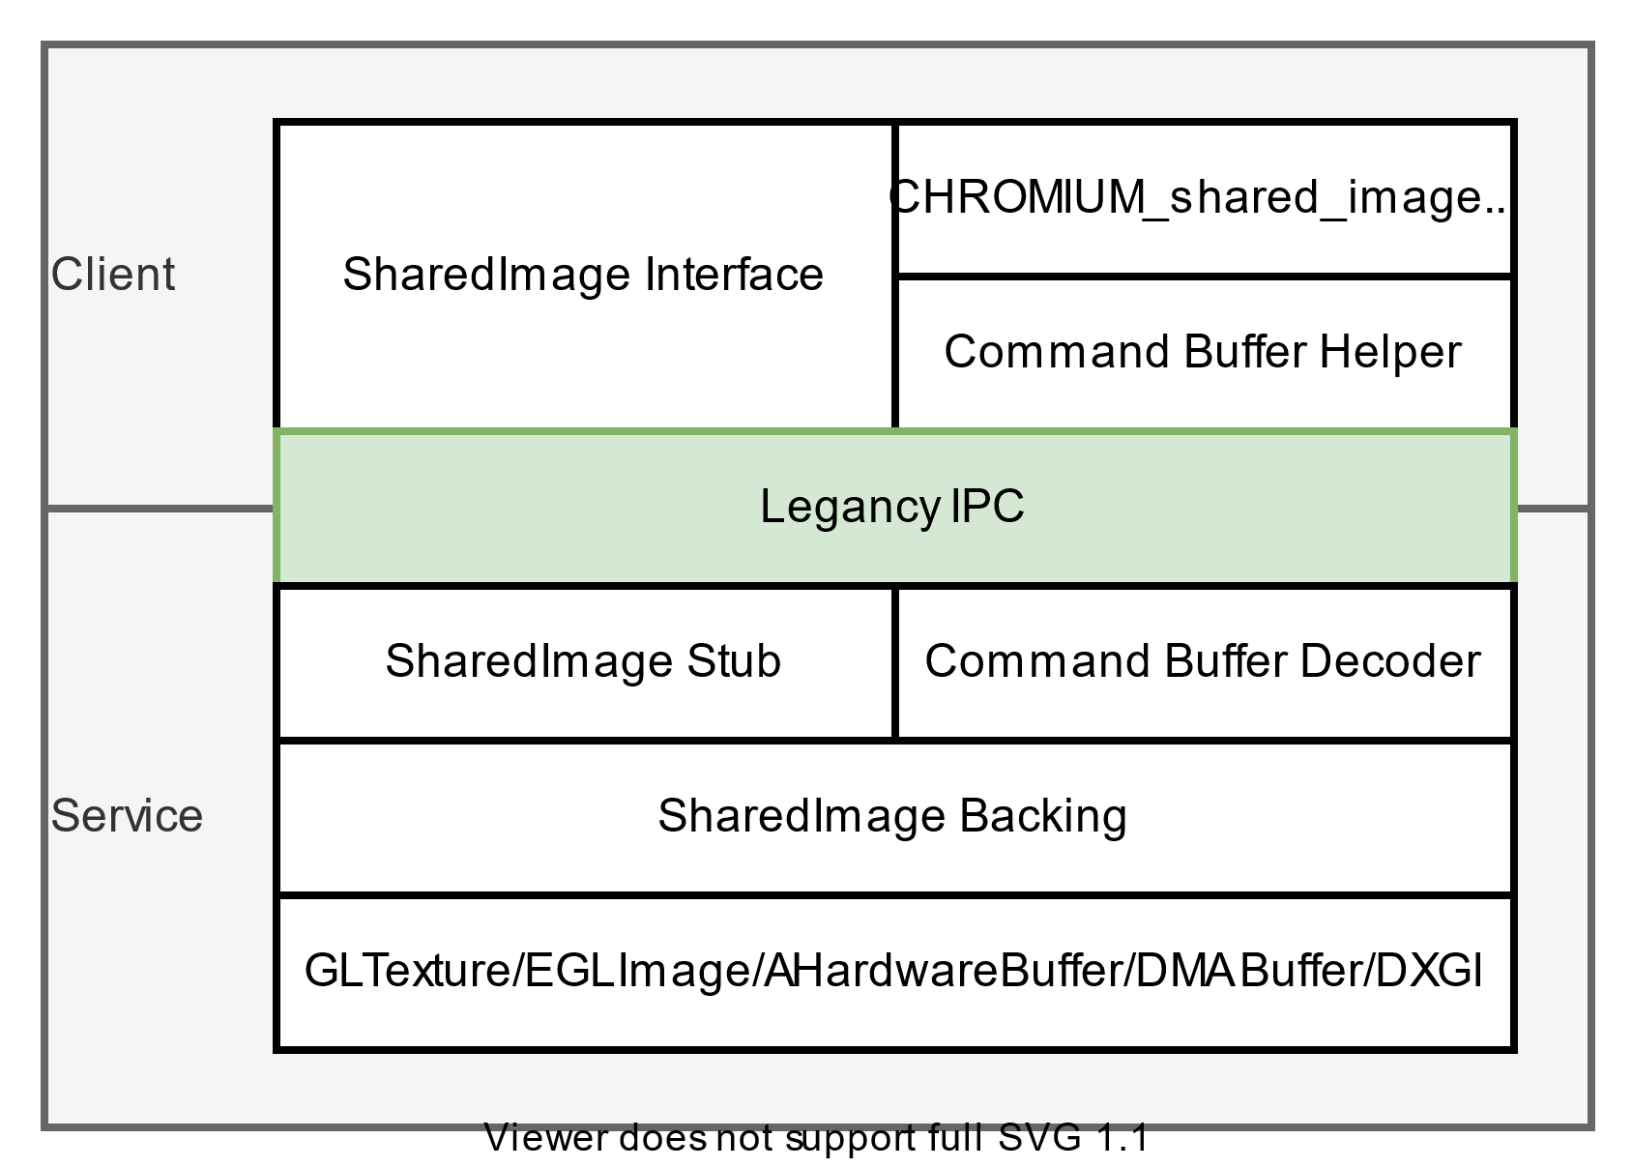

=== Predictive input ===
Algorithms could be used to help predict a player's next inputs, which could overcome the impact of latency in cloud gaming applications. Stadia's head of engineering Majd Bakar foresaw the future possibility of using such a concept to "[reduce] latency to the point where it's basically nonexistent", referring to this concept as "negative latency".
Predictive input is a technology that anticipates and suggests text or commands based on user input patterns and context. It's commonly used in various digital interfaces, including keyboards, virtual assistants, and gaming controllers. Here's how predictive input works and its potential applications in gaming:
- Text Input: In text-based interfaces like messaging apps or web browsers, predictive input analyzes the words or phrases entered by the user and predicts the next word or words based on context and previous input history. This helps users type faster and more accurately by reducing the need to manually enter every character.
- Voice Input: Predictive input can also be applied to voice commands in virtual assistant applications. By analyzing speech patterns and context, virtual assistants like Siri, Google Assistant, and Alexa can anticipate user intents and provide relevant responses or actions.
- Gaming Input: In gaming, predictive input can enhance the player's experience by anticipating their actions and adjusting the game's response accordingly. For example, predictive input algorithms can analyze the player's past movements, decisions, and gameplay patterns to predict their next move or strategy. This can be particularly useful in real-time strategy (RTS) games, where players must make split-second decisions based on changing circumstances.
- Adaptive Difficulty: Predictive input can also be used to dynamically adjust the game's difficulty level based on the player's skill level and performance. By analyzing gameplay data in real-time, the game can automatically scale the challenge level to provide an optimal level of engagement and enjoyment for the player.
- Personalized Gaming Experience: Predictive input algorithms can tailor the gaming experience to each player's preferences, play style, and skill level. By learning from past interactions and feedback, the game can offer personalized recommendations, content suggestions, and gameplay tips to enhance the player's enjoyment and immersion.
- Gesture Recognition: In motion-controlled gaming systems like the Nintendo Wii or Microsoft Kinect, predictive input can analyze the player's gestures and movements to predict their intended actions. This can improve the accuracy and responsiveness of motion controls, allowing for more intuitive and immersive gaming experiences.
Overall, predictive input has the potential to revolutionize gaming by making interactions more intuitive, responsive, and personalized. As technology continues to advance, we can expect to see predictive input algorithms become increasingly sophisticated and integrated into a wide range of gaming applications.

== See also ==
2010s in video games
2020s in video games
Remote mobile virtualization for mobile gaming as a service
Stream processing
Real-time data

== References ==
- "Cloud Gaming: Architecture and Performance" by Albert M. K. Cheng, Sang Min Park, and Qiang Duan. This book provides an in-depth exploration of cloud gaming architecture, performance optimization techniques, and challenges in cloud gaming systems.
- "Understanding Cloud Gaming: Platforms, Services, and Infrastructure" edited by Manuel García Sánchez, Jaime Ferragut López, and José A. Ruipérez-Valiente. This book offers a comprehensive overview of cloud gaming technologies, platforms, and infrastructure, covering topics such as game streaming, virtualization, and user experience.
- "The Game Belongs to the Cloud: How Cloud Gaming Is Transforming the Video Game Industry" by Jonathan J. Williams. This book explores the impact of cloud gaming on the video game industry, discussing topics such as business models, market trends, and technological advancements.
- "Cloud Gaming: A Game Changer in the Industry" by Zohair Al Sarraj, Jamal Raiyn, and Abdelfettah Belghith. This research paper provides an overview of cloud gaming technology, its benefits, challenges, and potential impact on the gaming industry.
- "Cloud Gaming: An Overview and Research Directions" by Haiyang Zhu, Zhe Yang, and Jianfeng Ma. This paper discusses the current state of cloud gaming technology, research challenges, and future research directions in the field.
- "Cloud Gaming: A Survey" by Bo Zhang, Hongbo Liu, and Hongke Zhang. This survey paper provides an overview of cloud gaming architecture, streaming protocols, quality of service (QoS) metrics, and research challenges.
- "Cloud Gaming: Architecture and Performance" by Albert M. K. Cheng, Sang Min Park, and Qiang Duan. This research paper investigates the architecture and performance of cloud gaming systems, including network latency, server scalability, and user experience.

